Time and Eternity

1960 Birthday Message of Master Kirpal Singh
(published in the February 1970 edition of Sat Sandesh)

Time is an interminable eternity with no beginning and no end except as man has for his own convenience, in his own limitations, tried to limit it and make separate divisions out of it. With all these ruthless vivisections, eternity remains ever in love with the products of time and is willing to unfold the secrets of heaven and earth to him who reposes his trust and faith in her benignity.
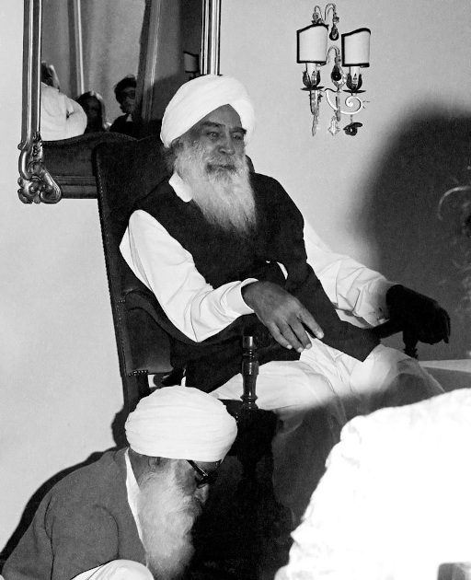
Dom Hotel Cologne Germany 27Aug72

Birthdays are but arbitrary milestones of life's journey on earth, but they do serve a very useful purpose, all the same. As one crosses each division of time and steps into the other, he is reminded of a stage left behind and finds himself a step nearer to the journey's end. Each birthday, therefore, offers a splendid opportunity to the traveler to know where he stands, how he has fared on the path of life, what progress he has made, and what he intends to do next with new hopes, new aspirations, and new resolutions for the new year that lies ahead of him. It is an occasion for taking a comprehensive view of the stock-in-life gathered already to be garnered thereafter, and it can, as such, be profitably made use of to the best advantage.

On a day like this, I can only ask you, who have been put on the Path Godwards, to turn within and see, each one for himself or herself as to the measure of advance made in the spiritual field. Blessed indeed are those who have done so and to them my message is that they should persevere in full faith and confidence in the Master-Power overhead and work hard to regain all the inheritance which is theirs and of which they have a foretaste. To those who are yet standing still for one reason or another, I would commend some sort of active striving with a will and a purpose. After all, each one has to make an experiment on his own and no one can vicariously do it for another. Again, there is no ill without a remedy, and this sovereign and potent remedy is to be applied, whether we will it or not, by oneself if we desire a cure; or else the disease of ignorance shall continue to persist and persist endlessly as it has done through ages upon ages.

Last but not least, the door of Salvation is open to all. It is not a prerogative for any one sect, caste, or creed or even a religious order. Whosoever may run, can reach it. "Knock and it shall be opened unto thee" has been the message of saints and seers since the beginning of time. God is the God of all mankind and His Grace shines equally on all, but they alone who turn towards Him derive the greatest benefit. 'Love' is the master key that unlocks the door leading to the 'Kingdom of Light.' "Love and all things shall be added unto thee" is an axiomatic truth that has stood the test of time. It is, therefore, said — "Love God with all thy mind, with all thy heart, with all thy strength, and with all thy soul."

My message today is none other than that of Love. Learn ye, therefore, to love all creatures as yourself. Live in and for the love of all and the Lord of Love shall reward you manifold in return for the sake of His own Divine Love. That is His Law, eternal and immutable. Try to cultivate a loving and a living faith in His Goodness and nothing shall stand in your way on the Path.

This is the only message that you can have from me on this occasion. I extend to you all my loving greetings with a Soulful Love and Benediction. May you all arise and awaken in His Consciousness.
