He Gives His Hand to Everybody

Evening Darshan, September, 1969
Chapter 1 of the book Light of Kirpal

The Master comes for the sinners. He takes those who come to Him, up for a while. But to stay up there requires purity. So to even the most sinful, the Master gives a boost and takes him above body consciousness, gives him a peep through the Door; and he sees Light. Whether good or bad, sinful or virtuous, the Master gives them all first a boost to come up. Then, if they are not attached to the world too much, they will be able to remain there. For that reason, they must become purer.
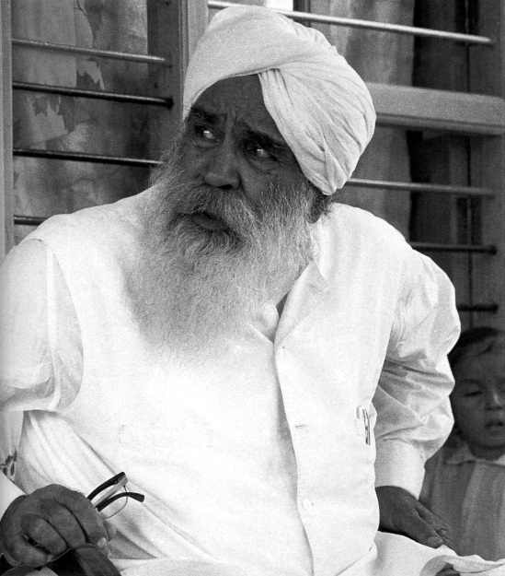
Sawan Ashram September 1969

So He gives His hand to everybody, even the most sinful. He loves the sinner but hates the sin. He gives all who come to Him a boost and something to start with. Unless a man is raised, taken up, how can he see the Light? So when he reaches It, it is just like a man who had gone onto the roof by going up the stairs. When he gets near the roof he sees light. When he is withdrawn from outside and rises above body consciousness, he comes nearer to the place where that Door is, the tenth Door, and only then is he able to see the Light. This the Master gives to everybody.

But the point is, if a man is attached too much to the world, naturally he must be changed; for that reason he is asked to lead a very virtuous life. I will give you an example: nowadays we have drycleaning, but previously the washerman used to strike the clothes against stones to take out all the filth; even if it was the filthiest cloth, he did not mind. He never refused it. He took it; he just cleaned it. It was his job; he was the washerman, you see. Now the times have changed. In the old days it was arduous work, but nowadays the drycleaning [of the Master is done] by sweet ways, by inducement, by loving words. “All right, please come up, leave all this behind.” And the spiritual diary that the initiates are all asked to keep
is only meant for that purpose. But the Master gives a boost to every man. He accepts everybody. He comes for the sinners as well as the virtuous.

Quite a few of us here saw You give a boost to 165 people the other day at their initiation. And of those, 63 of them saw the Master inside, and others — in fact all of them — had experiences of one kind or another. Would they all have had experiences like that had it been a group of non- Indians?

All get something. Whether they are non-Indians makes no difference. When I went to the West, you know, those who had been given initiation — even those who were never given initiation — all received something. My system has been to give free talks, then after that there was an hour of questions. Then all were invited to come to the meditation sitting, which was usually held the following morning. And those who came — even those not initiated — had some experience. One lady came to me. She said, “I don’t want to learn any theory. Just give me an experience.” She was given. It is the giving of a boost by helping the soul to withdraw from outside and go up there. So this happened in the West also.

There have been some who have described the Path that You teach as a science. And of course, most of us think of a science as something that can be repeated if you follow the exact instructions. But apparently there is an added element, namely the Master. Now, doesn’t the addition of this added element take it out the realm of pure science?

What is the Master? He is not the man-body. It is the Power working through — That gives the boost. A small child learns something from his father and mother and from his brothers. In school he learns from the teachers. Similarly in this way, Those who are adept on the way give a little way up. Not everybody can do it, only those who are competent.

Of course, there is nothing lost in nature. But sometimes things are quickened, just as a young fruit tree if left to nature will take about seven or eight years to bring forth fruit, but if in a scientific way it is given some scientific food, it will bear fruit in two or three years. So the way up is something given by a higher competent Soul to help another soul to have that experience. So this has been given in the West.

I went to Athens where I gave a talk, but I did not know the Greek language. A professor there interpreted. Then after that were questions and answers. At the end I told them, “All right, come to the meditation hour in the morning.” So about 50 or 60 people came; they all got an experience. Then people ran up like anything. So that professor has written a big book, telling how Pythagoras used to teach the same thing, how Socrates said such and such. They have put my photo in the book and told how I have revived this ancient science. So this is something given, you see.

But to maintain it, that’s the point now. We must not be so much attached outside. To live a normal life is all right. If you are attached too much to outside things, you cannot concentrate inside; you will be dragged outside. For that reason, the diary system is to be maintained. As regards a Master; He is Someone who can give you a boost. That’s the God in Him, not the son of man.

On a less high plane, do initiates who propose others for initiation take on the part of the karma of the people they propose?

No, not in the least. It is only God Who sends — they become only the medium. Those who are ready, God sends them, brings them in contact through some source. They come to know through somebody, or through a newspaper, anywhere. They are brought in by Him — they are brought in contact with the Master. He sanctions their initiation through somebody over there who is not a Master, but that Master Power works everywhere. So with a little thought He sanctions, gives them a boost over there. They get their experiences, most of them get something. If not, it is because they are either in a hurry, or they come very tired. I then tell the group leaders to give them another sitting when they are buoyant and fresh. So that Master Power works all through. That’s the Christ Power, God Power, Guru Power, or Master Power.

My understanding of it is like if you put a little pressure on a button that controls TV or radios, the pictures and sound appear.

One other question, on the subject of vegetarianism. If an initiate has the care of a helpless invalid in his home and the invalid says, “I must have meat to eat,” does the initiate pick up karma if he prepares meat for that invalid?

If he is bound by duty, he is not responsible. For instance, if I am a servant to somebody, or in the army and an officer orders me, “Do this,” I have to do it. For that the officer is responsible. It is the officer who gives the order, “Fire,” and this boy has to do it. The officer is responsible. You are bound; you can’t help it. The only thing is, you must not become the doer; then it’s all right, you are saved.

Baba Jaimal Singh was a military man; He served in the firing lines. He was once ordered to distribute meat to the regiment. He did it; He was bound by duty. When you become the doer, you are responsible. When the officer orders, “Fire” — fire! It is not of your own initiative that you are doing it. That’s the main underlying thing.

In other words, if you accidentally wash an ant down the drain you are not responsible, but if you deliberately do it, you are?

The point is, even as we breathe we sin. We kill so many insects which we do not see. So for the sake of higher things you have to sacrifice the lower things. Do the minimum sin. Even to eat vegetables is a sin, I say. There’s life even in stones, as there is in vegetables, in insects, reptiles, birds, animals, and man. But the point is, it develops more in insects, still more in birds and animals, and is most developed or manifested in man.

All this creation is made of five elements: earth, water, fire, air, and ether. In vegetables there’s the least; there is one element, water. If you put some vegetables to dry in the sun, ten kilos will gradually become half a kilo. So the major portion is water. But life is there. In reptiles it is more. It is more sin to kill a reptile. There is still more sin in killing a bird; there is still further sin in killing an animal. If you kill a man, where life is fully manifested, you are hanged. If you kill a quadruped or some animal, you are not hanged; you have to pay the fee, the price of it. If you kill a bird, who cares for it? You follow me?

This consciousness is manifest most in man. So in man, five elements are fully developed; in animals only four of them; in birds only three; in reptiles only two; in vegetables only one. To kill an element — vegetables — enables a man to live, yet that is also a sin. So this sin cannot be escaped unless you become a conscious co-worker of the Divine Plan.

That is a most interesting phrase. What is a conscious co-worker of the Divine Plan?

When a man sees that He is the doer, He is the controlling Power, he sees that Power working, manifesting in all. When he sees he is a mere puppet, that means he is a conscious co-worker of the Divine Plan. Everybody runs to do something — for instance, I will give you an example. A man is sitting at the powerhouse. The whole machinery is run by the powerhouse. But the man sitting in charge at the powerhouse sees nothing can be done without the Power. He becomes a conscious co-worker when he sees that Power is working. Then you are not the doer. Don’t commit. You will be saved in that way.

And there we get right back to where we started. In order to see that Power, we have to go through that Door we talked about.

Surely, there a lift is given. The lift is given by the Master to come up there, to experience something to start with. If a man tries to remain there, he must be up to that level. Try to. Each man is in the make. Hitherto, in the old days, I tell you, men were first prepared. Only when they were ready did the Master give them something. Now those days have passed; nobody can now live with a Master for years and years and years. Now they must give something and be told to come up to that standard by self-introspection. Times have changed.

I believe there is a story involving either You or Your own Guru Sawan Singh Ji in which someone came to You and said, “Please lift me up.” It was a person who was not ready. And the person was lifted up and got struck by lightning. Would You talk about it?

No, no, not lightning. One day at Meerut a man came up for initiation. He was given a sitting, and he did not get any experience. I again gave him a sitting. But he would not leave his body; he was always conscious of the breathing, he would not leave outside things. So I told him, “All right, you have had a sitting. I have explained what to do. If you will do it, you will have it; you will surely have it. Go and sit at home and do what I have told you.”

In the morning he came back; he had not got it. I told him, “Well look here. If you simply turn your face as I tell you, it will be easier for you. If you are dragged, you will fall down and be hurt.” He said, “No, I don’t mind. You drag me.” When he was dragged a little he struck his head at the back and fell down unconscious. So that is dragging, you see?

You should simply turn your face that way; don’t think of the world outside, don’t think of the body below, don’t think of the breathing going on. This is the only method. Just turn your face here and you’ll be given. That is easier. In that case there is no anti-power working. When you are stuck too fast outside and anybody drags you, naturally there will be pain.

What happens to initiates who are given initiation and then fail to meditate?

That seed is not lost. No power can spoil it. That will grow, grow, and grow, sooner or later, when convenient circumstances arise. So such-like people when they suffer some sickness, some untoward circumstances, naturally they say, “Oh God, what have I done?” If a man turns, then he comes around. I have seen cases like that. My Master used to say, “I give a long rope. Let us see how far he goes.” Then with a little tug, he comes and answers, you see.

Even if he does not do anything in this birth, that seed is not lost. He will reincarnate at the level of man, not below, because the seed cannot grow anywhere else. Man is in the make as I told you. Some are ready, some are not so ready. So a man who has got this seed and has perhaps done something in the past, that counts to his credit.

Suppose a man leaves a school in the primary class; in the next school he won’t read from the first primary again, he’ll start ahead. But there is one thing very definite, I tell you: Love is a great force. If you have love for the Master, even if you are a sinner, you will be dragged like anything. What is sin? To let your attention be attached to the outside things — maybe good or bad things, excuse me. Even if it is attached to right things, it is an impediment. You are attached! You must withdraw. Those who have love for the Master, where will they go? Where the Master goes. But that should be the ruling passion with love and full faith — only in that case. That is rare, of course.

But for those who have done a little work, it is like a canker in the wood which sometimes eats the inner wood itself; outside it appears all right. Those who are given initiation, that works like a canker, I tell you. Outwardly they appear worldly, then slowly, slowly, slowly they are detached. Towards the end they say, “Oh God, lead me on.” Help is also coming from within; the Master is there always. We must turn our face to Him, that’s all. The more receptive we become, the quicker results we will have.

Thank you, Sir.

All right, I also thank you for your questions.
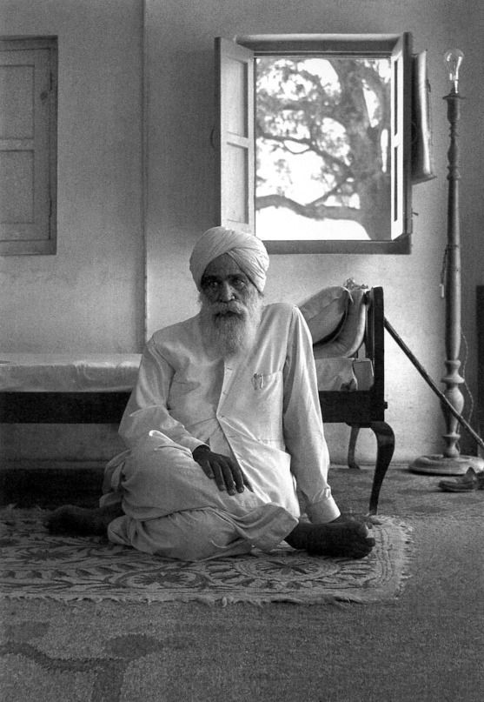
Manav Kendra 1970 - temporary quarters

