Keep A Vigilant Watch

The Light of Kirpal, Chapter 50 – Questions and Answers

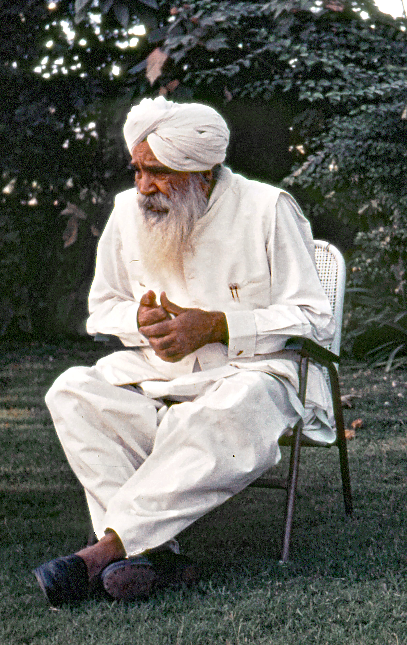
Sometimes we repress. It is like sometimes a man exerts
to get rid of his shortcomings, but that does not really rid
him of his failures. It does not make him clean.

Why exert; what for? There is no question of exerting. At least you came to know the shortcomings you have. Then try to weed them out. Keeping a constant, vigilant watch over all your thoughts is what is wanted. If you fail five times today, try not to fail more than two times tomorrow. Weed out one by one. That is only [accomplished by] watching.

Moreover, you are not to think in the negative way. “I am a sinner. I am a sinner. I have done such and such.” That won’t do. You must try to reduce. “I am a sinner; well, let me be sinner no more.” What did Christ say to that lady who committed adultery? He asked the people what the punish-ment for that crime was in their law. They said that she should be stoned to death. “All right, if there is anyone who has not committed that act, go throw a stone on her.” Who would dare? No one. Then he said to her, “All right; do no more.” This is what is wanted.

Always brooding, “I am a sinner. I am sinner.” won’t do. You are not a sinner; you have committed sin. You have be-smeared yourself with filth. Wash it away. You are gold ore that comes from the mines. You are pure gold if you clean it [the filth] away.

So, I told you, God plus desires is man. Man minus desires
is God. If you watch yourself in that way for some time, you will have habit, and habit will turn into nature. You won’t dare to tell lies or anything like that.

You say we should be aware of our thoughts. If in meditation some thoughts come up . . .

Why does something come up? Because your attention is slackened.

Yes. If in meditation, something comes up and we become aware of it, won’t this slacken our attention more?

Why does something come up? Because your attention is slackened. I think these thoughts won’t occur to you if your attention is not slackened. Our subconscious reservoir of mind is overflowing in all these thoughts. Do one thing, wholly and solely. That is why I say in the meditation instructions, “Be fully engaged, constantly, without a break. Look minutely to follow what is there.” For that period, no other thought will enter in. It is only when you see wide, thoughts will come in. At the same time, I told you not to talk or think negatively, always positively.

You are a soul. You are a child of God. You are micro-gods. You are of the same essence as that of God, only besmeared. Wash it away. What you have done today, don’t do it tomorrow. A vigilant watch is required. Keeping the diaries means only that. Understand, once and for all. And that also won’t do sufficiently unless you then live it.

You say, “Poison is poison, that will kill me.” You’ll create trouble in your stomach and all your veins. “Poison — I am eating poison.” Well, stop taking any more poison. Whatever past poison taken can be washed away. Do no more. Our Master used to say always when someone came to Him, “Master, I have committed this sin; will You forgive me?”
“Is there anyone here who can take his burden of sin? Who? Nobody? Then do no more; do no further. Do Bhajan.” So do no more, please — that’s all I can say.

