The Solicitude of the Master

Godman, Chapter 27, by Master Kirpal Singh

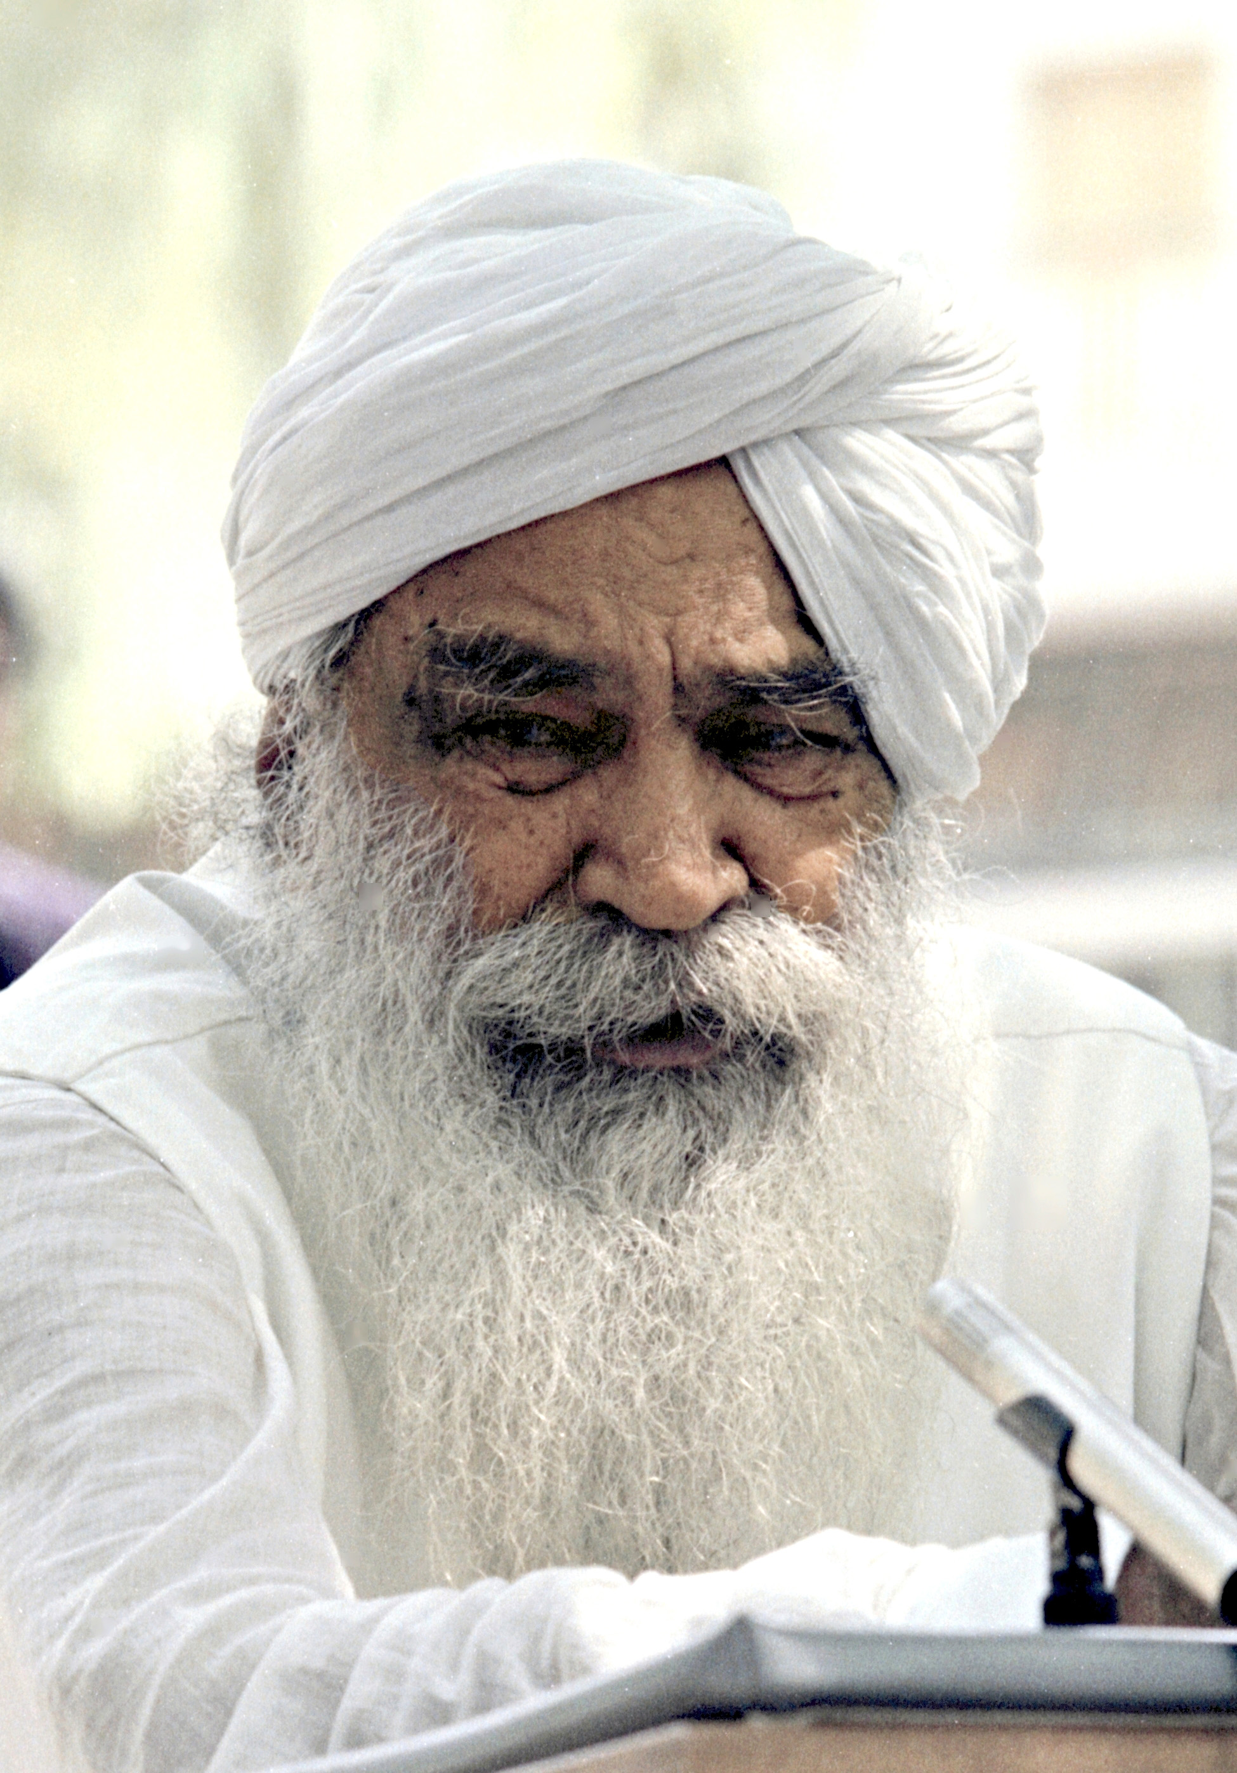
The relationship of the Master and the disciple is unique in character and we find no parallel to it on earth. Still, Saints have tried to make us understand something of it. While all worldly connections and ties are more or less tainted by selfishness, the relation between the Master and the disciple is purely one of selfless love.

Just for the sake of analogy, we may consider the love of a mother for her child. An infant at birth is just a mere helpless mass of tender flesh and bones. He cannot express himself and his needs, nor can he look after himself, but the mother takes tender care of the tiny piece of humanity. She attends to his every need and looks after his comforts. In his happiness lies her happiness and in his sorrow she feels distressed. Day and night she tirelessly works for the child’s welfare and does not consider any sacrifice too great. She denies herself everything so that her child may have all that she can afford to give and is ready even to lay down her life for his sake.

As the infant grows, he begins to imbibe his mother’s love.
The kindly rays of love pass from eyes to eyes. In mute language he begins his first lessons in love. Gradually, the toddler is taught to speak, at first in broken syllables, and the mother’s delight knows no bounds at every success in her endeavors, until he grows big enough to look after himself.

In exactly the same way, when a person is accepted by the Master he takes a second birth, as it were, into the Master’s house. He comes into the Master’s fold full of worldly attachments and dyed deep in the darkest shades of mind and matter. He is so identified with his body and bodily relations that he can never think that he is something apart from them.

With all his worldly wisdom, whatever riches, name, and fame he may have, he is blank in matters spiritual. Having lived all his life on a sensual plane, he is conscious of nothing but sense pleasures which are the end and all for him.

With his birth in the Master’s house, the Master takes upon himself an immense load of responsibility. By individual instructions and attention, he gradually weans the jiva from sense pleasures. He tells the disciple that he is neither body nor mind nor intellect, but something more glorious — soul or spirit — and has been endowed by Nature with various faculties to serve a high purpose in life. By spiritual discipline, the Master enables him to free his mind of mental oscillations. Now he develops a state of equipoise, and with it he begins
to evaluate life from a different angle. His entire outlook is changed and a consciousness of spirit dawns in him.

He is no longer a slave of his senses engaged in sensual pursuits, but finds an inner satisfaction, peace and serenity which keeps him engrossed all the time at the seat of the very Self. All this is the work of the Master, and much more besides. To wash clean a jiva from the impurities of the world is no mean task, but it is absolutely necessary for a spiritual life.

He has to be pulled up from his senses, mind and intellect, and this no one but a Master can achieve.

To stop the course of the mighty rush of sensory currents flowing headlong into the world, and to hold them at one center, is a gigantic task in itself. The next job of the Master
is even more important than this.

After the preliminary cleansing process, he pulls scales from the inner eye and gives it vision and Light; and he breaks the seal on the inner ear, making the jiva hear the inner music of the soul. By his individual attention and care he makes an adept out of trash and scrap — capable of understanding and enjoying the unspoken language and unwritten law of God, and of doing actions without the aid of outer organs and faculties.

The Master takes care of the disciple with his own life impulse.

Blessed indeed is the Master, who by his instructions purifies us through and through.
Satguru cuts asunder all the shackles of the disciples.

As Wordsworth sang of his sister, so a disciple sings of his Master:

She gave me eyes; she gave me ears; and humble cares and delicate fears;
A heart the fountain of sweet tears, and love and thought and joy.

The Master always saves his disciples, no matter how danger-ous a situation they may be in. His protecting arms serve as a shield and buckler, and the disciple leads a charmed life, as it were. The Master does all this simply because he has taken charge of a jiva; there is no obligation on the disciple’s part, nor does he necessarily know about it.

Again, the Master takes upon himself the burden of his disciples’ sins and iniquities.

All thy misdeeds to Him imputed be
And all His righteousness devolved on thee.
—Dryden

He takes in his own hands the entire process of winding up the karmic impressions of the jiva. Having freed him from the sensual plane by reversing his sensory current so that it flows upward, the Master renders him incapable of sowing any more karmic seeds for future harvesting; and whatever tres-passes he may still commit through weakness of the flesh, the Master himself gently and firmly deals with here on earth, leaving no debit balance to be carried forward. In this way, the account of Kriyaman karma (present deeds) is settled and squared.

Next come the Pralabdha karmas, which determine what we call fate or destiny, and because of which we come into the world. The Master does not touch them and happily the disciple weaves his way through their spell.

Through the compassion of the Lord all trials and tribula-tions fly;
Satguru himself saves a jiva from all harm.

Last but not least, the Master feeds the jiva with the Bread of Life and quenches his thirst with the Water of Life (Naam) until he grows into spiritual adolescence and is capable of a certain amount of self-reliance. The touch of the spark of Naam (God-in-Action or the controlling power of God) burns out the storehouse of unfructified karma of ages upon ages (Sanchit or storehouse), thus rendering them incapable of germinating in the future.

Satguru keeps his sikh (disciple) on manna and elixir;
So very kind is the Master to his disciple.

I am the bread of life; he that cometh to me shall never hunger; and he that believeth on me shall never thirst.
—John 6:35

The protective care of the Master is much more than that of
a mother for her child. He ever keeps His loving eyes on his disciple and guards him from all that is harmful, for his love knows no bounds.

As a mother tends her child and ever looks after him, Gives him food and nourishment for growth all around; So does the Master look after his beloved with Godly love.
As mother loves the child, and fish the water, so does Master love his own man.

In this respect, distance is of no consequence and it does not count with the Master. His long and strong arm can reach everywhere, and his penetrating gaze can pierce through all space.

His hand is the hand of God, and the power of God works through him.
—Maulana Rumi

Wherever a disciple may be, however extreme his outer circumstances, the Master is always with him and guides him
at every step, for that is his eternal promise:

Everyman, I will go with thee and be thy guide;
In thy most need to go by thy side.

A skylark is a pilgrim of the skies, and yet she hatches her
eggs by giving them her whole attention. Similarly, the Master always keeps his disciple within his gaze, nurtures him with the Water of Life — the seed of Naam sown in the seeker’s soul — until the spirit is able to break through the triple-shelled egg (physical, astral and causal sheaths) and shines forth in her own self-radiance.

O Nanak! Master takes care of the disciple with His very life impulse;
He keeps him safe in His own hands and looks after him all
the time.

Love alone is the cementing force that binds the Master and the disciple. Through unbounded compassion he delivers God’s message to suffering humanity and prays that they may be saved from the imperceptible fire in which all are being consumed.

Maulana Rumi says:
He calls the people toward the Kingdom of God;
He prays to God for their forgiveness and salvation.

Satguru is the real friend of the disciple. He saves him from tense and hopeless situations. He comes to his aid when he has despaired of all hope and relief, and is surrounded by seemingly powerful forces arrayed against him. From time to time the disciple feels the overpowering influence of the Master working for his good. At times he works in ways that are difficult for the disciple to understand. Just as a mother waits in the early morning hours for her sleeping child to awaken, in the same way, even more anxiously, the Master looks forward wistfully to the time when his disciple, steeped in deep ignorance born of matter and mind, will raise his head, look toward him and gladden his heart.

The loving care of the Master becomes more manifest at the time of the disciple’s final leave-taking from the world. While all his relatives and friends helplessly wait beside the sickbed, and the doctors declare the case hopeless, the Luminous Form of the Master appears to take charge of the departing spirit and guide it to the new world, to the judgment seat of God.

After that, he takes it to whatever region he thinks best, for further discipline and advancement on the path.

Serve the real Satguru and secure tightly the riches of Truth;
At the last moment he shall come to thy rescue.
He alone is a friend who accompanies me on my last journey, and stands by me before the judgment seat of God.
My Master is all in all and the source of all comforts.
He links me with the transcendent Brahma and comes to my aid at the last.

Maulana Rumi says:
O ignorant fool! Quickly take hold of a guide; for then wilt thou be saved from the horrors of the beyond.

All our worldly ties and connections are of an ephemeral character. Some leave us in poverty, some in adversity, some in illness. A few may stay beside us all through life; but they too fall away at the time of death. But Satguru is the real friend, who always overshadows the disciple and keeps his protecting arms around him wherever he may be. He stands by him at the time of his death and even goes along with his spirit as a guide to the other worlds.

O Nanak! Snap asunder all ties of the world, and find some friendly Saint;
World attachments shall leave thee even in life, while the Other shall stand steadfast unto death and beyond.

A soul awakened to Reality by a Satguru cannot be a prey to the messengers of death but must go with the Radiant Form of the Master, which comes to receive it when it casts off its physical raiment.

Kabir Sahib tells us that gold does not rust, nor is steel eaten by worms; so, a disciple of the Master, no matter how good or bad, never goes to hell.

Gold attracts not rust nor steel the worms;
The disciple of the Master will never go to hell.

The Master is the Master indeed, both in this world and the next, and helps a jiva in both the worlds. There is no greater friend.

I have taken hold of my Hari; He is my sustainer and is ever with me.
He is a guardian angel in both the worlds; for almighty and ever merciful is the Satguru.
I have with me Satguru, who helps me in all my needs; blessed is the Satguru, who reveals God to me.
There is no friend greater than Satguru; he is the Protector, here and everywhere.

If and when a jiva comes across a Satguru, he may thank his God, for the Guru underwrites life eternal for him. Full of compassion as he is, he unhesitatingly helps him through difficult situations, and without the least thought of obligation.

Maulana Rumi says of him:
Kind hearted and selfless is the friend;
He helps in dire difficulties and hard times.

The Guru is pledged to help the helpless. Through sheer compassion he extends his saving grace to all humanity. His company is the most beneficial; with Guru by his side, one may successfully defy millions of enemies.

When Guru is thy shield and buckler, millions of hands cannot strike thee down.

Truly blessed are the jivas who have had access to the charmed precincts of the Satguru, for they have nothing to worry about here or hereafter.

The world bows to him in adoration; regions divine anxiously await his advent;
For perfect is he who is in touch with the Perfect.

How very very fortunate are the disciples who are under the shadow of his holy wings; in their lifetime and beyond, they march with leaps and bounds on the grand trunk road of spirituality.

