Be True to Yourself and Live
for Others

The Light of Kirpal, Chapter 72 – Questions and Answers
March 2, 1971

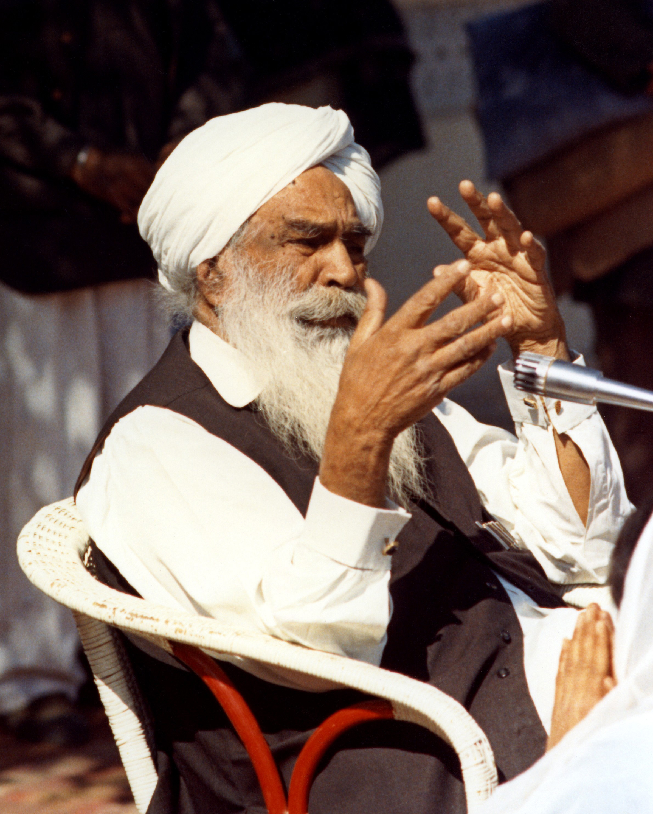
In America, some Satsangs have thousands of dollars in funds in the Satsang account, but Satsangs, to my know-ledge, never do anything with it for the help of the people around in their communities or anything, and I wonder what advice You might have on that behalf?

For instance?

For instance, in ___ there were migrant workers one time, and I think they were actually starving at one time.

Who?

Migrant workers. They are a low class of workers that travel, migrate around the country, just picking crops and so forth. They were very much in a tight spot one time, and that would have been an ideal time for the Satsang to help with food and this and that thing. Is there any general rule that the Satsangs could follow in helping the very needy in the communities and so forth?

You see, it is the duty of everybody. For instance, if some needy man is there, and you are close to him, you may help to the extent you can. If more is wanted, you might ask the group officer. If everybody goes up to the group officer, “Well, help this cause, help these people,” then? Whatever is received is required to be used in so many other ways, is it not? Do you follow me? If only a little help is required; everybody’s duty is to help. If, for some reason or another, man has to be helped more, then in that case you might approach the group officer. But if everybody does it, “Help this man, help this man, help this man, help this man;” the group officer has to see to the other needs also.

We cannot doubt their integrity, you see. Those group officers in charge have to determine how to spend the money. There is not only one man to be helped but it has to be used in other ways too. They have got a traveling fund. They have their own tour funds. Sometimes they have to receive somebody and spend; this only those can know who are in direct touch. The others cannot know.

Suppose somebody, some other heads of other departments,
a big man is coming, he has to be received and this is also an expense. So, the group officers in charge have to see to so many other things. That money is not only for the help of others. It is to spend in other ways.

If there is a need, everybody should do his best. If you feel it has to be used, then you might approach your group officer, “Will you help out?” It is his duty to do that. But when everyone from every side comes, “Help this, help this, help this,” then? It becomes a little hard for him. When you are in charge of that group, then you will also feel that way, is it not so?

They send their reports, regular reports. What is balance, what is valid, what is received during the month, what they expended. They send their regular accounts here. So, they have, apparently, good control over it.

Is it not advisable to just give money to people who need, rather than to give them something that you are not sure will help them? They may spend the money in a way not appropriate.

You see, how can you tell? If you find he acts and poses, and he is really not due that, then . . .? Help when you see somebody really is in need, starving. You might help, that’s all right. But if man only acts and poses, this and that thing, then in that case naturally he will use the money for some other purpose. That is why Swami Ji says, “Give to the Master . . .” When you give to the Master, he does not use the money for himself. He will spend for the good of the people at large, and for the Mission. He won’t accept anything for himself.

But you will earn pleasure; you will earn his pleasure when you help others. So, for that he is responsible. You are absolved from all responsibilities. But it does not mean that if someone is starving, you let him starve. Give a help, food. Whether or not he misuses the money, you do not know. If man is apparently needy, starving, his children are starving, this and that, naturally you will help him.

Now I have got this Manav Kendra started. So many lakhs of money have been spent for it. I come and go; regular accounts are kept. I live on my own pension, you see. I also subscribe to the Satsang from my pension.

Once I went to the West, this was torn (Master points to his shirt), and somebody came up to me, “I will get you one. Do you want one of those?” “No, no, I must buy it using my own means.” I hope you remember. Everybody is there to help each other. I give my regular tithe, even more. As a son of man, I should do it, is it not so? As a son of man, I am not absolved from duty as a son of man, you see.

If you see that to be strong, to be rich, to be affluent is good for your own self, why would it not be good for others also, is it not? Make others happy, affluent, to the best you can; have good wishes for all. The only trouble arises when we extract things for our own good. This is wrong. If each man learned to live for others, there would be happiness in the world. He, who would like to make others happy, will become happy. If you won’t let anybody die of hunger, I think you will also not die of hunger. If each man lives for that purpose, then there is happiness in the world. The whole trouble arises when we want to live at the cost of others. This is wrong.

The Masters teach sometimes by parables and sometimes by straight talk. There is a parable given that Lord Vishnu invited all people, good and bad, the goddesses, gods and those who were not gods. The gods came up and took their seats, and the others also came in, and a big feast was served.

Lord Vishnu stood up, “Well, dear friends, I am very glad to receive you here. It is all for you, but there is one condition — you should not bend your elbows to put the food into your mouth. “Strange, if you don’t bend your elbow, how can you eat?” Those who were not gods said, “He is certainly making a joke of us. He won’t let us eat.” They became angry and left.

Now only the gods remained. “Well, it is Lord Vishnu who is saying that, there must be some meaning, purpose behind it.” Then it struck them. “All right, very easy; feed the person next to you. Let us feed each other.” Let others eat. Do you think you will remain without food in this way?

Only if you learn to live for others there is happiness. We have always learned to live for our own selves — at the cost of others. That is why there are all these dissensions at home, abroad and everywhere. A very little thing.

I think it is a very simple principle if you would follow it: Make others happy, that is all. We want to squeeze money, you see; squeezing very cleverly. Not letting others know, by acting and posing. After all, the cat must be out of the bag, will it not? How far can you go on doing this? These things reflect here. Others do not say openly, but they see and they resent. Do you follow me now? That is why I always say, be true to your own self. If you are true to your own self, you won’t deceive your own Self, the God which is within you, and the Master which is also within you. Each should try to live for others, to whatever little extent it is possible, then all these worries will soon be over.

I will tell you one incident in the time of Guru Amar Das. He sent for a certain man who was by the river giving a child a bath. Somebody told him, “Master wants you.” He left the child there and ran. “What are you doing?” “My Master has sent for me.” He left his child — how confident he was. Then the other man naturally took care of his child.

So, suchlike love is required between the disciples. One’s face is this way, the other’s face is another way, each trying to live for his own vanity or for one reason or the other. If you say you love the Master, and don’t love one another, it means you’re a liar. These principles are forgotten.

Each one wants to become a boss and naturally there’s trouble. The boss may be right sometimes, not always. So, humility . . . sweet words imbued with humility is the panacea for all ill-will. Try to live for others; I think this is a very simple motto. We want to hold money for ourselves, squeeze money, misuse, misappropriate. Then the whole trouble arises. People see; they may not say anything. Don’t you think that what you are doing within four walls, people see? They have eyes and ears. Even the walls have got ears. So that is the greatest motto, not to deceive your own self.

Two disciples came to a Master. They wanted initiation. He gave each man one pigeon to kill in a place where nobody would see. One was very clever, went out around the wall and killed it. The other was tossing about here, there, everywhere. He could not find any place where nobody was seeing.

So, he came back in the evening, “Master, I have not been able to find anywhere where nobody would see.” “Who was there?” “Well, at first I was seeing the pigeon, and then he was seeing me too, so I could not find any place.”

Deeds of darkness are committed in the dark. All these misunderstandings, misconceptions, the people see. They go very deeply down into the very way you are living, and they form opinions from their own level of thinking.

People even write wanting to know the reasons [for the beha-vior of some initiates]. I always write them, “Well, all are not saints. They are on their way to perfection.” What should I reply? The main lesson is don’t deceive yourself. One word. We do not go deeply into what we know. What does that mean? “Don’t deceive yourself.” Reply is there. Even if others complain about you, the Satguru is complained of also. These are the reasons.

So long as our daily living is not developed . . . How can you deceive God? Can you mock God? Deceive God? If you are true to your own self, you are true to God; you are true to God. Is this not the remedy for all our daily dyings at home or in Satsangs everywhere? The group leader in charge and others should be more polite, more sweet, more humble, then . . . Kind words don’t cost anything.

These are the things to be learned by self-introspection.
What does that mean? If you live in that way, there will be radiation. Others will be convinced by your living. And, moreover, don’t go by the hearsay of others. Unless you see for your own self and hear with your own ears, only then believe; otherwise, don’t believe. We simply become the judge, taking sides with one or the other, then the whole trouble arises. Suppose a man says such and such a man is not honest. Someone else says that he is not honest. Don’t believe that he’s not honest. See for yourself. He might be using money for some honest purpose. Just hear what he says. When the two things agree, then you have got the right perspective on which to judge.

These are the details I am giving you. The very word is given. Don’t deceive, be true to your own self, live for others, that’s all. I simply say those who do not live for others are not men, they are beasts. Beasts live for their own. They fight with others for the sake of their children, for the sake of the belly. Two dogs fight for a morsel of flesh, killing each other. If a man also does the same, then is he a man? He is not a man.

If you follow two things: be true to your own self and live for others, all troubles will be gone. All differences will be quite gone. So, naturally, when the head in charge hears that some-one is taking sides, some others take sides without seeing, without hearing, there is trouble. So, two things will help you much: be true to your own self; and, live for others. Is this not a remedy for all diseases of our daily dyings? Each man is complaining. If he has got that ideal life, then where is the trouble? There will be nothing to create any troubles within the mind. You will be sincere, you are true to your own Self, to your God.

If you are true to your own Self, to the God in you, then whom do you have to fear? The more you go deep down into these things, the more you will find wonderful things. Is this not the remedy for all our daily dyings?

Having been the president of the World Fellowship of Religions and having had contact with many heads of the social, political, and religious sects here and abroad, I have found very few really sincere. They are political at heart. Heads of different religions, social bodies, and even political bodies come up to me.

Once I went to Austria. Then some Italian and Tyrolian people were fighting. A war was about to break out and the governor, whom I met, said, “I am in a dilemma, what to do. My country is out for war. What should I do? I cannot decide.” I told him, “What is good, do at once, what is not, does not appear good, wait. Try to reconcile by good will.” And there was no war.

That governor wrote back to me, sent me word through somebody, “When are you coming back? We need you.” Very simple things, you see, but you must be sincere to your own self. We are not sincere. We say something, we do something else, thinking that nobody sees us. God sees us.

If you come in contact with that Power within you continuously, you’ll become the abode of all virtues. These things come up of themselves without striving for it. Have you read Jap Ji? We read, we don’t go into it, deep down into it. If you hear and go deep down into the words, “all virtue,” you become the abode of all virtues. Just like when a crop is cut and the grain is taken out. The crop is in a big field but at one place all grain is piled up. So, there is a book behind each word of the Master, I tell you.

The Masters’ teachings are always very brief, simple, to the point. They don’t need any bombastic words, struggling, drawing inferences. They use simple words. These two things: Be true to your self and live for others. What a big book behind these words: what a sermon behind them.

On my Diamond Jubilee, they wanted me to give the teachings in a few words. I gave them only, “Be good, do good, and be One.” Few words. They wanted the teachings very briefly, ‘Be good, do good, and be One.’ You are already One, as man, as soul and worshipers of Higher Body.

The main purpose behind Manav Kendra is that: Be good,
do good and be One, at the level of man. Service of man is service all around. It is in furtherance of Ruhani Satsang, you see. Yes?

This third word, ‘be One’ . . .

Are you not One already? Unity already exists, we have forgotten. As man we are born with the same privileges from God. As soul we are all brothers and sisters in God. As a worshiper of some higher Power called by different names meaning the same, we are already One. Unity already exists; we have forgotten. Master’s job is to bring all children of God together on one platform, to understand each other. They are already One.

This is a big sermon behind, ‘be One.’ I am not telling you anything new, quite common-sense talk. These things you can not have in big lectures. When you go deep down, then you hear the Music of the Spheres, you see then. So, awake and arise and stop not until the goal is reached. The goal is, we are already one with God, in God. We are all brothers and sisters in God.

“Blessed are the pure in heart (in whose heart there is no ill will for anybody), for they shall see God.” “Peace be unto all the world over, under Thy will, O God.” Where there is love for God, there is love for all creation. That is the criterion. People ask, “What is purity of heart?” Where no thought other than that of God arises in you — that is purity.

You want to be pure, no reservations — have no other thought than God. Is this not the definition of a pure heart? If these things are explained in your talks, in your meetings, people will turn out, as these are the basic teachings of all Masters who came. All said the same thing. I think these things will help you. Anyone else? Good question. There may be something wrong somewhere, maybe due to what I tried to explain; it is not all wrong everywhere.

In the future, if thousands of dollars are accumulated, would it be better not to help the needy?

Did you follow what I said? I built hospitals, free schools, etc., for the poor and needy, old men’s homes — what is that for? This was built with the money from you people and others. I also subscribe, you subscribe. I am only the custodian, that is all.

So, I explained to you, if a man comes in contact with you directly — he is dying — you help, sacrifice yourself. Try to live for others. That is all right. I own no membership here. Nothing. No imposition. When some give, I determine whether they can afford it or not. I refuse many times.

So, if each man follows this principle, there will be peace. There are so many stories about this in the lives of great men. One man had to go on a pilgrimage to Mecca. He collected some money for spending on the way. The night before, he heard a number of people were dying of hunger, having had
no food for so many days. He gave all of his money to them and did not go to the place of pilgrimage.

We go to a place of pilgrimage where God resides or where some Godman had resided. If you serve God in man who is dying of hunger, is that not a true pilgrimage? God told him, “You are the first man whose pilgrimage has been accepted.”
If the dogs all around you are howling . . . They may not know, but the God is in them, is it not?

So, living in society is required. Where you find somebody really needy, sacrifice your own interest. You are not doing anything to please others, but to please your own self. So, that is what is meant by, “Be true to your own self.” Follow these things. You will find that these things are not ingrained within you unless you come in contact with that Power constantly.

You may leave Him, but that Power does not leave you. It is hovering around you. Music of the Spheres never leaves you, thank God. That is the Master within you. You may find some incident when there is trouble, but within, there is the Sound. He is saying, “I am with you.” We have been put on the very Golden Way. But it is for us to now maintain and develop it — that is all. Man has to work for everything. A strong man revels in his strength and a weaker man wonders how he got it. He did not get it in one day. So, all this awaits you.

Guru Nanak says, “Why should we preach to others to know who is the living God? If Master is Word made Flesh and the Word in them radiates, no preaching is necessary.” The more you come in contact with that physical form inwardly, you will develop everything of itself. We do not realize how fortunate we are to have been put on the Way — really; to have contact with that.

So, go on with it — God will help you. There is nothing to be feared, nothing to be disappointed about. You will get something. God will help you. All right.

